2 of 10

Previously
A war on two fronts! Raven and his warriors have been on the trail of Dominor, who has been murdering connections to his past. Whilst the Alaunus Queen Mother Ayeleth and a second team of warriors are in the Age Exchange Reminiscence Centre, and have stolen the Dragon’s Heart, to return it to the palace and stop Nevar getting his hands on it. Little do they know, their fight is not over yet

Scene 1
Cyrus’ old shack, 22:35 BDT
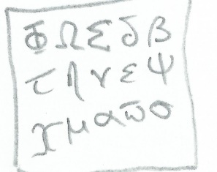
The Translation
Raven and his warriors walk into the shack and spot a piece of parchment
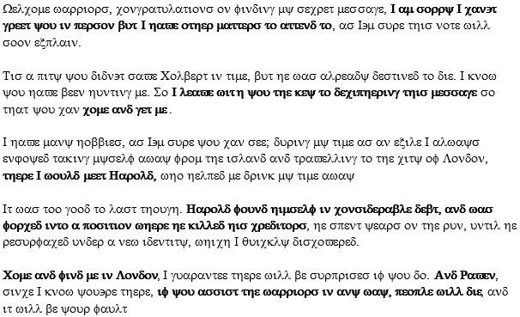

Raven: Another hidden message, Dominor seems to enjoy leaving these (he heats up the parchment but the message this time is coded in strange symbols, a translation guide is appears beneath it) another of Dominor’s traps. Warriors, use the guide to translate the message. I will keep guard in case Dominor’s forces arrive. Let the challenge begin (he steps outside)

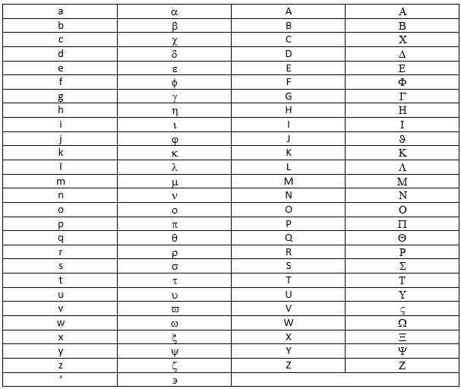

The warriors see the message in strange symbols, and the translator guide for them to use. The warriors all get to work translating it at once, with complete disregard to what the others are doing. Realising this would be pointless, Hagal and Jocal break off and decide to translate different paragraphs; they try to stop the others but fail to do so.

Hagal quickly works through the first paragraph, managing to translate its contents before any of the other warriors manage to do so, not long after Jocal completes translating the third paragraph and moves onto the fourth. The other warriors continue a slow translation of the first paragraph, with little to no communication between them

Hagal’s efforts on the second paragraph are proving fruitful, as letter by letter she manages to translate the sentences Dominor has left for them, Jocal continues her translations and eventually manages to translate the fourth paragraph, they decide to work together on the final paragraph, each tackling one sentence

Raven: Dominor’s forces could return here at any moment, you must hurry

Whilst Onion, Vansem and Ardem near completion on translation on translating the first paragraph, Jocal and Hagal begin work on the fifth paragraph. Eventually Jocal and Hagal complete the translation, as the remaining warriors finish their efforts on the first paragraph, they seem astounded by the efforts of Jocal and Hagal.

Welcome warriors, congratulations on finding my secret message, I am sorry I can't greet you in person but I have other matters to attend to, as I'm sure this note will soon explain.

Tis a pity you didn't save Colbert in time, but he was already destined to die. I know you have been hunting me. So I leave with you the key to deciphering this message so that you can come and get me.

I have many hobbies, as I'm sure you can see; during my time as an exile I always enjoyed taking myself away from the island and travelling to the city of London, there I would meet Harold, who helped me drink my time away
It was too good to last though. Harold found himself in considerable debt, and was forced into a position where he killed his creditors, he spent years on the run, until here surfaced under a new identity, which I quickly discovered.

Come and find me in London, I guarantee there will be surprises if you do. And Raven, since I know you're there, if you assist the warriors in any way, people will die, and it will be your fault

Jocal: I am disappointed but I wish that I would've told my fellow warriors to focus on one paragraph in that challenge
Hagal: I am a bit angry and disappointed because both Jocal and myself tried to let the warriors focus on one part of the message rather than the whole thing.
Ardem: I should have reread the message more thoroughly and understood what each symbol meant, as I admit I was rushing a bit when figuring out what meant what.
Onion: I guess we could have pitched in more to help with the message as it was very hard to keep a translated alphabet at the side and also to find exactly how the message goes.
Vansem: In reality we should have contributed more to the challenge so that we could get a better message. All I am hoping for is that we succeed in the future with this kind of stuff.

Raven: We must move quickly, Dominor’s forces are upon us, we must head to London. (He creates a portal) come (the warriors follow Raven through the portal)

Scene 3
Age Exchange Reminiscence centre
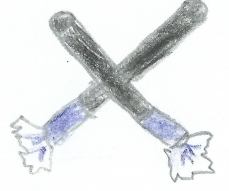
Escape from the museum
The warriors and Ayeleth try to escape the museum, but they are confronted by several robbers, armed with crowbars, bats and escrima sticks

Ayeleth: Warriors, you must take care of this, I must maintain my spell to ensure the police do not arrive.

The twelve thieves seem momentarily conflicted about attacking people so young, Ayren uses this time to devise a strategy, which she quietly shares with her team-mates. With the thieves over their conflictions, they attack the warriors, minus Cosni who has hidden, preparing a stealth attack. Narex kicks a bat out of a thief’s hands. Netea comes in from behind, picks up the bat and hits the thief in the head with it. The blow knocks him unconscious.

Cosni comes out of hiding and, without being noticed, holds one of the thieves in a sleeper hold, the other thieves maintain their attacks on the other warriors. Ayren and Fyraf use a similar strategy, with Ayren disarming the thieves of their weapons, and Fyraf picking them up and using them to knock them out. One thief armed with a crowbar is quickly dealt with as Ayren uses a quick jab to knock the weapon out of his hands, while Fyraf hits him with it.

Cosni takes down the fifth and sixth thieves by knocking their heads together; Narex manages to disarm her fourth thief of his weapon. Unfortunately the thief picks up the weapon before Netea, who was busy knocking out the second thief that Narex had disarmed. Ayren and Fyraf act a little more in sync, with Ayren using spin kicks to distract the thieves whilst Fyraf hits them with their own weapon.

Cosni takes out the 10th thief, leaving the 5 warriors surrounding the remaining two thieves, the two thieves seem scared, especially after Narex and Ayren disarm them of their weapons, they try to make a run for it, but Cosni is behind them and she stops them in their tracks and Netea and Fyraf knock them out from behind

Ayeleth: Well done warriors, now let’s get out of here (they run out of the museum)

Netea: We needed to escape with the dragon's heart, so I don't feel sorry for the thieves
Cosni: I enjoy the stealthy approach as it's not loud, so nobody else is alerted.
Aryen: I'd like to think that I play the part as our team's strategist, maybe even a great one, considering I have devised three successful plans already, but I don't like to think of myself too highly.
Fyraf: The thieves we took out may well have suffered from concussions, but they are criminals, and therefore deserve every part of their punishment!
Narex: I feel a little conflicted about this challenge as it all happened very quickly and it was hard to prepare myself.

Scene 3
Paddington Train Station, 23:00 BST
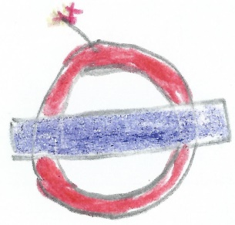
The warriors exit the station and see the advertising screen, the screens begin to flicker and Dominor’s face appears on it.
Dominor: Welcome to London. You're here earlier than expected, but I already have plans. There is a bomb at Mile's End station; only you can disarm it, because if anyone else tries I detonate it remotely. You must travel from your current location of Paddington station, but... You may only travel a maximum of 3 stops on any one line, do so and (he swivels the trigger in his hands) good luck. Oh and if Raven stands within 10 feet of the bomb, I detonate it.
Raven: I will track down Dominor’s target, find that bomb. Let the challenge begin (he takes off)

Without knowing how long they have until the bomb detonates, the warriors are quick to study the tube map they have been presented with. Ardem, keen to redeem her honour after the translation trial, points to the others a viable route to the bomb. With the route agreed the warriors each swipe their oyster cards and pass through the security gate.

The warriors head for the Bakerloo Line, which after a brief wait they board. They wait as the tube-train departs, getting frustrated at the speed of the train as it makes its stops, when the train reaches Bakers Street Station, they leave the train, and following Ardem they make it to the Metropolitan Line, the train arrives after a few precious seconds waiting, and they quickly board it

After the warriors make it to King’s Cross St Pancreas, they depart from the train and run off the platform, narrowly avoiding bumping into other people, they head to the Circle Line, and board the train that has just arrived. After a frustrating wait aboard the train, the train arrives at Moorgate, they quickly depart the train and head for the next one.

The warriors run to the Hammersmith and City Line platform, where the next train they need to board departs from. After the train arrives the warriors board and eventually the train arrives at Liverpool Street Station, where the warriors would make their final train change. The warriors finally make it to the Central Line and board their final train

After another few minutes the warriors arrive at Miles End, largely abandoned because of the bomb threat. Electronic screens are guiding them to the bomb, so the warriors all run in the direction they are being pointed, with Ardem falling behind at this point. Jocal is the first to arrive at the bomb, and seeing no tools to disarm it pulls all of the wires out, the bomb is disarmed, but Raven comes with bad news

Raven: I found Harold, he’s dead; Dominor’s game was a distraction while he finished him off.

Jocal: It was very challenging for the challenge and I was disappointed with the outcome after hearing the news that Harold had lost his life.
Hagal: To be honest, I was surprised about the challenge mainly because of the information that it was sending and that threw me off a bit.

(They are joined by Ayeleth and her warriors)
Raven: You have the Dragon’s heart?
Ayeleth: The warriors have done well, they have retrieved the artefact; we are en-route back to Alaunus, what has brought you here
Raven: It would appear Dominor is here, and he has allies, even he couldn’t project himself onto the advertising screens without help.
Ayeleth: Some-one who could hack into those things, it can’t be a long list
Raven: Aye, but I’ve been disconnected from such information for too long, I don’t think I could name the person. But I think I know someone who can, if I can get in contact.
Ayeleth: While you attempt that, do any warriors wish to swap? (The warriors all shake their heads) very well, I bid you adieu (Ayeleth and her warriors are transported away, Raven takes out the piece of parchment he found in Harold’s pocket and reveals its message) an address, warriors, we have a destination, we must make haste, or risk Dominor claiming another victim (they move on, a voice comes out of the shadows)
Arron: Raven
Raven: Arron, I have not seen you since me return
Arron: Things have gotten crazy out there and it’s only getting worse, I can’t stay. I just came to investigate a hack job.
Raven: I understand, but perhaps you could clue us towards Dominor’s potential ally?
Arron: Dominor? Never heard of him. But I can guess who his partner is. Noah Cuttler, AKA the Calculator. He’s an agent of the Masters, but has some free reign on his projects. Be careful of him, he’s not a guy you can mess with easily.
Raven: Thank you, that’s all I wanted to know.
Arron: By the way, you’ll be walking for hours to make it to that address on foot; I’d consider taking the tube
Raven: Oh. Yes, come warriors, we must move quickly (they move down into the tube station)

Scene 4
Royal Palace, 23:45 BST
Ayleth and her warriors arrive at the Palace Entrance
Guard 1: And who are you?
Ayeleth: Ayeleth and her warriors
Guard 1: Not good enough I’m afraid, we’ve heard rumours of demons able to disguise themselves as humans. You’ll each have to be checked (Ayeleth raises her hand and the grass grows)
Ayeleth: Satisfied?
Guard 2: You may enter, but you warriors could be fooling you as well, we’ll have to test them. Demons aren’t very smart; a riddle should easily determine whether or not they’re who they say they are
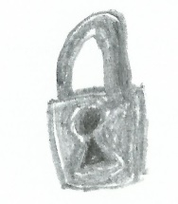
The Guards’ Riddle
Netea steps up to the guards;
“I have millions of eyes, yet I live in darkness, I have millions of ears, yet only 4 lobes, I have no muscle, yet I rule 2 hemispheres, what am I?” The guard asks. Netea ponders his answer, and eventually has one he thinks appropriate for the riddle
“The human brain” he says, and the guard lets him through

Ayren is the next warrior the guards quiz:
“I am worse than Satan but greater than God, the poor have me, the rich want me, and if you eat me, you will die, what am I?” Ayren takes some time to consider the riddle, but soon enough he has an answer
“Nothing” is his answer, and the guard lets her pass
Narex is the third of the group that the guards pose their riddle to:
“I have a face but no eyes, hands but no arms. What am I?” Narex is unfazed by the riddle, and soon has his answer
“A clock” he says and the guard lets him through

Cosni is the fourth warrior to be quizzed
“I am the type of room you cannot enter or leave. Raise from the ground below. I could be poisonous or a delicious treat. What am I?” Cosni considers the riddle but soon has an answer
“Mushroom” Cosni answers correctly and is allowed to enter the palace

Fyraf is the last warrior the guards’ question:
“The more you take of me, the more you leave behind. What am I?” Is the final riddle. Fyraf soon has an appropriate answer to the riddle
“Footsteps” Fyraf replies, the guard likes the answer and lets him enter.

Aryen: I was pretty comfortable with the riddle, I'm not terrible at them, so I guess that benefited well here.
Fyraf: I was a little wary at first, I didn't know how good at riddles I was, but I seemed okay once I thought about it.
Narex: I felt apprehensive when presented with the riddle because I wanted to get it right but I calmed down once I thought about it.

The warriors regroup with Ayeleth, and enter the throne room to greet Erina.

Erina: Welcome warriors, you have recovered the Dragon’s heart
Ayeleth: We have the artefact, but we should be prepared, if Nevar finds that we have it, he’ll likely launch an attack on the palace. The danger has only just begun

Next time on Raven: The Reckoning
Puzzle at a Hotel – Can the warriors find Dominor’s latest target?
Attack at the palace – the warriors man the catapults
And the warriors have to fight off demon hordes and metahuman enforcers

The characters in this story are entirely fictitious so don’t try copying the challenges yourself

