4 of 8

Alaunus was rebuilt from the ashes, but now new threats threaten to tear it down again. Former S.H.I.E.L.D. commander Rolfe Phillips discovered that the Riddler has a vast array of high-tech weaponry that could destroy the city and more. Meanwhile the white demons of the forest have been quiet, but for how much longer?

Scene 1
Doomstadt, Latveria, 19th November 2029, 17:00 CEST
A small S.H.I.E.L.D. dropship flies over the city, where massive explosions are occurring thanks to a Civil War on the ground
Pilot: Commander Phillips, we’re at minimum dropping altitude
Rolfe: Excellent. Remember, our priority is keeping the piece, set blasters to stun only, we do not want to escalate things. Hover packs on? (Billy Dellik raises his hand) yes, Dellik
Billy: Sir, are we even authorised to intervene in this Country?
Rolfe: Not even slightly. On my mark. (doors at the side of the ships open) GO GO GO! (They all jump through the doors using their hover-packs to slow their descent so they can land safely upon landing, troops wearing green cloaks and metal face-masks immediately open fire upon them, their body armour is able to take most of the shots, they fire back, using the stunners to knock these troops out. Flying machines wearing the same clothing as the soldiers fly ahead and begin blasting them) damn it, we need to take those out of play! (The others have all separated) fine, I’ll do it then (he fires at one of them but the armour deflects the shot. He opens coms) hacking team, come in
Computer: S.H.I.E.L.D. Hacking division is currently occupied; we aim to bring you online within 10 minutes (music is played as Rolfe shoots a few more soldiers with this blaster)
Hacker: This is S.H.I.E.L.D. hacker 919, how may I assist you today?
Rolfe: I just tagged a remote controlled machine with an access chip, I need you to trace where the control signal is coming from
Hacker: Damn it, why are you in Latveria?! You know our orders; I have to cut off this… Wait… It’s Rox Ven, he’s controlling them
Rolfe: He’s been on S.H.I.E.L.D.’s most wanted list for years, where is he?
Hacker: The control signal is within 100 yards of your location, it’ll be giving off quite a lot of heat, so it should be easy enough to find. (Rolfe conducts a heat scan of the area, finding a nearby shanty with a significant heat signature)
Rolfe: Thanks (he hangs up and opens coms to his team) I just got intel that Rox Ven, known cyber-terrorist is in the area, Dellik, Jones, back me up
Billy: Sorry sir, but we’ve got the leader of the Doom squad in sight
Matthew: We got the leader of the AODs in sight, we could set them up together and take the first steps to ending this war.
Rolfe: (Sighs) do it. I’ll handle this personally (He kicks the door of the shanty down and finds Rox Ven typing at the computer) it’s over, surrender!
Rox Ven: Over? It’s barely begun…
Rolfe: We have both side’s Commanders; we’ll get them to make peace!
Rox Ven: Doubtful
Billy: (On coms) sir, we’ve been conned, the commander’s a hologram!
Matthew: (On coms) he’s a hologram sir
Rolfe: They’re both dead, aren’t they?
Rox Ven: (Laughing) and you’ve just revealed it, now the sides will descend into chaos, no-one knowing which side they’re truly on until this wretched country becomes nothing at all and I rake in their money and technology.
Rolfe: (Switching his blaster to kill and pointing it at Rox Ven) I can’t let you do that
Rox Ven: Go on then, shoot me (5 copies of himself appear, each copy in turn speaking) or me (Rolfe changes the position of his gun between the 5 of them) it’s already over, there’s no going back from what has happened. You have failed!
Rolfe: (Snapping) SHUT UP! (He fires at one of the Rox Vens, it’s revealed that all of them were holograms, but the one he shot was a Latverian child in holographic disguise, he looks on in horror as she collapses from the bullet wound, Billy bursts the door down)
Billy: We’ve been given extraction orders, sir, we need to get to the border, now! (He sees the child) oh my god!

Raven: The Fallen

Scene 2
Warrior Academy, 24th February 2033, 08:00 UTC
Rolfe is frozen in the spot with a completely blank expression
Gemma: Rolfe, Rolfe! I said, we’ve recovered the shell casing from the bombs, it’s covered in more of that binary code (Rolfe snaps out it)
Rolfe: It might be a clue to another hostage, give it to the warriors to translate. (Gemma heads away, leading Raven with him)
Raven: Are you alright?
Rolfe: Not really. When I signed up for this, I just wanted to teach kids how to survive, how not to make the mistakes I did. I never wanted to draft them into a war.
Raven: It’s unfortunate that more often than not war comes to us whether we like it or not.
Rolfe: I talked to the Mayor last night, he’s not bringing in S.H.I.E.L.D. in fear of escalating things
Raven: The Mayor has to think of the interests of everyone, his position is unfortunate and puts more pressure on the warriors
Rolfe: Where are the police? Where are our own military?! The Riddler’s just one guy!!
Raven: One guy with a gun pointed at the heads of several hostages with his demand being that only the warriors attempt their rescue.
Rolfe: I know, I know, but it’s frustrating. We’re relying on kids to do their jobs and we’ve lost several of them already!
Raven: It’s unfortunate!
Rolfe: Unfortunate! UNFORTUNATE! THE WARRIORS ARE DYING! HOW YOU BE THIS NONCHALANT ABOUT IT!?
Raven: Because I couldn’t live otherwise. These are not the first warriors I’ve seen die for a cause. I’ve seen more than I can count and every day I hear their screams! Look, I can’t guarantee more warriors won’t die, but I guarantee this: I will do what I can to keep them alive and I know you and Gemma will do the same. (He pats Rolfe’s shoulder) come, we have work to do

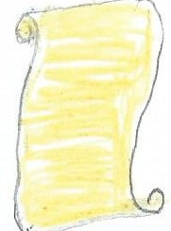
Resolution
Gemma approaches the warriors, they stand up
Gemma: We recovered this code from the bombs, the Riddler’s left us another clue, he’ll be relying on you to translate it. Good luck (she leaves the room)

01010111 01100101 01101100 01101100 00101100 00100000 01101001 01110100 00100000 01110011 01100101 01100101 01101101 01110011 00100000 01111001 01101111 01110101 00100000 01101000 01100001 01110110 01100101 00100000 01110011 01110101 01110010 01110110 01101001 01110110 01100101 01100100 00100000 01110100 01101000 01100101 00100000 01100010 01101111 01101101 01100010 01110011 00101110 00100000 01011001 01101111 01110101 01110010 00100000 01101100 01110101 01100011 01101011 00100000 01110111 01101111 01101110 00100111 01110100 00100000 01101100 01100001 01110011 01110100 00100000 01100110 01101111 01110010 01100101 01110110 01100101 01110010 00101110 00100000 01010100 01101000 01100101 00100000 01101110 01100101 01111000 01110100 00100000 01101000 01101111 01110011 01110100 01100001 01100111 01100101 00100000 01100001 01110111 01100001 01101001 01110100 01110011 00101110 00100000 01010010 01101001 01100100 01100100 01101100 01100101 00100000 01101101 01100101 00100000 01110100 01101000 01101001 01110011 00111010 00100000 01110100 01100001 01101011 01100101 00100000 01110100 01101000 01100101 00100000 01110010 01100101 01110110 01100101 01110010 01110011 01100101 00100000 01101111 01100110 00100000 01110100 01101000 01100101 00100000 01110100 01110010 01110101 01110100 01101000 00101100 00100000 01110100 01101000 01100101 00100000 01110011 01100101 01100011 01101111 01101110 01100100 00100000 01101111 01110010 00100000 01110011 01101001 01111000 01110100 01101000 00100000 01110111 01101111 01110010 01100100 00100000 01101111 01100110 00100000 01110100 01101000 01100101 00100000 01100011 01101100 01100001 01110011 01110011 01101001 01100011 00100000 01101100 01101001 01101110 01100101 00100000 01101111 01100110 00100000 01001000 01100001 01101101 01101100 01100101 01110100 00101100 00100000 01110100 01100001 01101011 01100101 00100000 01100001 01101110 00100000 01101001 01110100 01100101 01101101 00100000 01101110 01101111 01110100 00100000 01100011 01101111 01101101 01101101 01101111 01101110 00100000 01100001 01101110 01100100 00100000 01100001 00100000 01110001 01110101 01100101 01110011 01110100 01101001 01101111 01101110 00100000 01101111 01100110 00100000 01110010 01100101 01100001 01110011 01101111 01101110 00101110 00100000 01010000 01110101 01110100 00100000 01110100 01101000 01100101 01101101 00100000 01110100 01101111 01100111 01100101 01110100 01101000 01100101 01110010 00100000 01100001 01101110 01100100 00100000 01110111 01101000 01100001 01110100 00100000 01100001 01101101 00100000 01001001 00111111

01010011 01110100 01110010 01110101 01100111 01100111 01101100 01101001 01101110 01100111 00111111 00100000 01001100 01101111 01110011 01110100 00111111 00100000 01010100 01101000 01100101 00100000 01101000 01101111 01110011 01110100 01100001 01100111 01100101 00100000 01101000 01101111 01110000 01100101 01110011 00100000 01111001 01101111 01110101 00100111 01110010 01100101 00100000 01101110 01101111 01110100 00101110

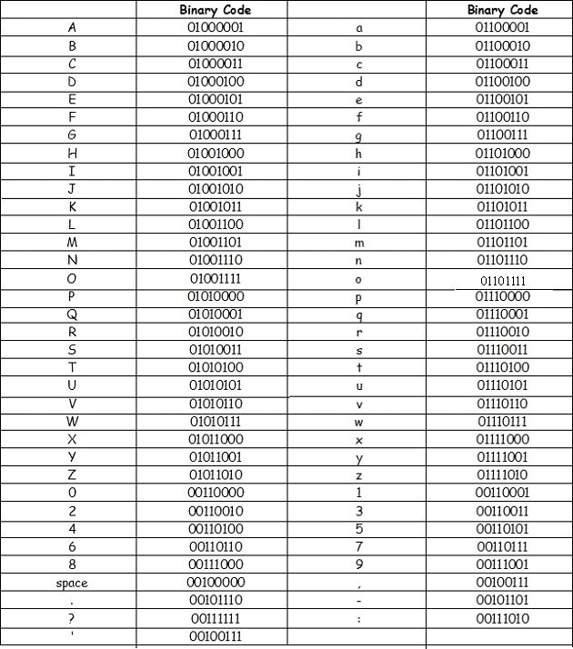

Landrek and Sileb immediately start translating the code, the others also make their attempts, Worbon particularly having success with the translation, the others seem to be struggling with this code.

With a lot of code to translate, time elapses quickly as the translation nears completion, but eventually it seems that Landrek and Sileb have completed their translations, and Worbon completes his soon after

They compare each other’s answers and are relieved to find that they’re the same, they urge the other warriors to stop as they read out the translation.

“Well, it seems you have survived the bombs. Your luck won't last forever. The next hostage awaits. Riddle me this: take the reverse of the truth, the second or sixth word of the classic line of Hamlet, take an item not common and a question of reason. Put them together and what am I? Struggling? Lost? The hostage hopes you're not.”

The Riddle briefly perplexes the warriors, but Landrek soon has an answer. Taking the first part to be ‘Lie,’ the second part ‘be,’ the third part ‘rare’ and the fourth ‘why’ they put the words together and form an answer, Library

Sileb and Worbon immediately agree to Landrek’s answer and given their success in previous challenges the others decide to take their word for it, they stand with Library as their answer.

Jedren: I misread the code, causing me to spend a long time trying to find out what went wrong.
Landrek: I was actually feeling fairly relaxed when translating the code, as had managed to crack several codes with great success earlier. I was surprised that I managed to get the second part of the riddle though, as it definitely proved to be a bit more complex than we first thought.
Sileb: We've already had to translate one code before, so it was a lot easier this time around. I was pretty stumped when it got to the Hamlet part, but luckily the others also figured out the code and we were able to move along from there!
Yvarina: I sort of stood back again here. The others seem much more capable at working the codes out quicker. I took some time to think about the quest, and I just really hope that I have a chance to show off my skills. So far nothing has really been a strong point for me.
Worbon: I felt like we were in with a good chance of deciphering the code because everyone had done well at it before. I was one of the first to finish which was a surprise and I thought I must've left something out but I checked with the others and thankfully it was correct.
Armsa: I just to block out everything else from my mind to translate the code
Tregan: I was fine taking a step back here as the others translated the code, my skills lie elsewhere

Gemma enters the room
Gemma: Well done warriors, it appears you have the location of a hostage. I’ll try and get some schematics from the Library to help you out.

Scene 3
Alaunus Library, 10:00 UTC
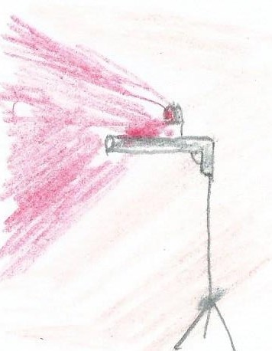
Sneak Attack
The warriors are at the library
Riddler: Oh, you’re here! Well good luck rescuing this hostage.
Gemma: (On coms) wait there, Rolfe is sending in some camo-drones to scout the area (the drones fly in, becoming invisible as they enter the library, they begin to record footage of the area) ok, we’ve got scans coming in, here’s how it looks

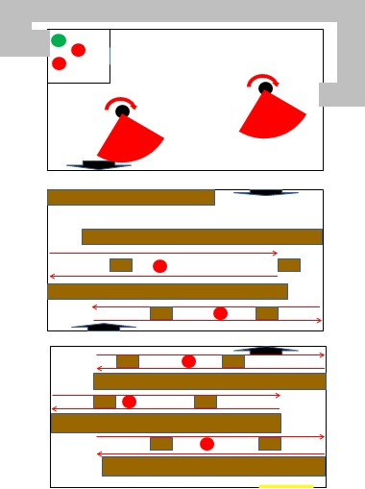
Ground Floor
Second Floor
First Floor
Key
Yellow Line – Starting area
Red Arrows – Guard patrol routes
Black upward facing arrow – staircase to upper floor
Black downward facing arrow – staircase to lower floor

Gemma: There are 3 guards on the ground floor where you are, you’re not gonna be able to take these guys head on, they’re all armed. First floor has 2 guards; both armed as well.
Rolfe: You see that? They’re wearing heartbeat monitors. If one of them goes off, we can say goodbye to the hostage, there might be a short delay on them.
Gemma: Sentry guns on the second floor, you’ll have to watch out for those. (The drones show infra-red images of the hostage through a wall) the hostage is in the private study room, 2 guards, locked door but there’s a ventilation shaft you can use to sneak up on them. Sentry guns should disarm once you’ve taken them down.

With a plan of the 3 floors described to them, the warriors discuss strategies for the challenge and Yvarina comes up with the agreed strategy for the rest of them to follow. Landrek, Yvarina and Worbon begin the plan, they wait at the side of the shelf as the guard turns around and once he’s far enough away they follow behind him, the repeat this strategy with the other guards and quickly make it to the second floor, Yvarina transmits a signal.

Tregan and Armsa set off on receipt of the signal. Tregan takes the lead as they make it past the first guard, they creep past the second and the third guard without incident and as Tregan joins Landrek, Yvarina and Worbon, they begin to sneak past the guards on the second floor, eventually they pass the 2 guards and head up to the third floor, keeping just out of range of the first sentry gun.

Yvarina soon realises that she’d made an error in her strategy in thinking that the sentry guns would be manned. Worbon and Landrek narrowly avoid the first sentry gun and know they’d have to pass the second in order to get into the ventilation shaft.

They manage it and head into the shaft, approaching the area where the two guards guard the hostage. Yvarina sends out the signal, accidentally stepping range of the sentry gun which shoots her. With little time to lose Worbon and Landrek take out the two guards before they could shoot the hostage.

With the signal transmitted, the others know to make their move, Tregan sneaks by the first guard on the second floor as Armsa lays in waiting, with an opportunity presented to him, Armsa takes down the guard. Tregan manages to do the same with another guard

Jedren passes the first guard as Sileb lies waiting to strike, Jedren passes the second guard and when an opportunity presents itself, he strikes on the third. The heartbeat monitors activate and the second guard is alerted. Jedren quickly manages to hide himself from him and takes him out as he passes by.

Worbon and Landrek open the locked door and the sentry guns are deactivated, they take the hostage through but notice Yvarina, gravely injured by the shot and dying. They alert the warriors to this who immediately come to join them, a great dilemma faces them now.

After some discussion, Sileb gives Yvarina the revival potion; the bullet dissolves and her injuries are healed, she has survived but the potion is gone. The vial of the enhancer potion was smashed where Yvarina fell, two potions lost to this challenge, but a grateful hostage survives

Jedren: I think we suffered a loss here - our aim was to all get through the challenge unscathed. Our resources were certainly not.
Tregan: It’s a disaster that none of us saw this coming, we should’ve remember what the sentry guns could do
Landrek: I feel as though it was somewhat of a success. On the one hand we managed to save the hostage from being shot a point blank range, but on the flip-side we nearly lost Yvarina. I think that our strategy wasn't as air-tight as previous missions, but hopefully we can learn from our mistakes and move on.
Armsa: We weren’t really successful here. We need all of the resources we can get to finish this journey.
Worbon: I think we failed this challenge quite miserably. The strategy seemed infallible beforehand but we overlooked a lot. I was so shocked when Landrek and I found Yvarina hit by a sentry gun and her loss has cost us dearly. I think it was the right thing to bring her back however. She has lots of valuable virtues that we might need in the future.
Yvarina: I almost ruined everything. My plan went wrong, which could have been fatal to one of my friends, but I ended up getting shot. I was bleeding out on the ground, I saw the faces of all of the warriors, and then I thought of home. I felt my eyes tearing, because I didn't want to die, but I accepted it. Just when I was ready to give up, Sileb revived me. He didn't hesitate despite it being my fault. I don't think we failed the challenge but I think I failed the team.
Sileb: We may have really screwed up our strategy, but we completed the mission and nobody had to die. Since I held the Revival Potion, I had to make the call, and I never want to see a person die in so much pain like that. Yvarina is a great warrior and friend to the entire team, and if we lost her, it would be devastating.

Scene 4
Warrior Academy, 13:00 GMT
Raven holds one of the turrets as Rolfe uses a key to unlock it
Rolfe: And we’re done, those turrets now have 360-degree rotation, in case we need to defend against any more attacks. Listen… about earlier…
Raven: No, it is I who should apologise. You are not wrong, these warriors are barely fledglings, it is a lot to ask them to do what they do at such a young age. But young minds have the potential to wield some of the waning magic of the island. I was told of your time in the military but I sense there is more to your tale.
Rolfe: You might say that… (They hear a demon-like roar)

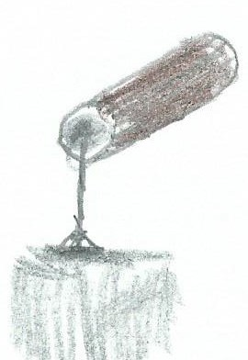
The Fallen Invade
Rolfe: (Speaking through megaphone) man the turrets! We’re under attack!
Raven: The arrows?
Rolfe: Vibranium, I’m told it’s been effective against magic before (Raven walks away) where are you going?
Raven: To introduce them to my own brand of magic (Raven transforms and flies away)

With the demons closing in on the Academy the warriors split up to man the remaining gun turrets. Landrek and Tregan volunteer themselves to be the ones firing. Sileb and Jedren follow Landrek whilst Yvarina, Armsa and Worbon follow Tregan

Landrek makes it to the gun turret, it is already loaded with a single belt of arrows, 150 in total, he sets the gun and points it towards the demons, he cranks the handle and several arrows shoot out, all of them being blown off course and missing the demons. He realises that with the range of the weapon, the elements need to be accounted for.

Tregan is at the other gun turret and they notice that other warrior units have dispatched a few demons, but many more remain. She takes to her turret and prepares to fire. She fires a few shots but not unlike Landrek, the wind blows them off course.

Sileb and Jedren try and help Landrek compensate for the elements. They think they have done some and they try again, Landrek cranks the handle and the arrows fire, striking a demon down, they move the turret as they shoot to strike more and soon a full row of demons have been dispatched, but as has 1/3 of their ammo

Worbon, Armsa and Yvarina try to help Tregan position the turret to strike the demons, they are closing in on the academy, she cranks the handle, firing the weapon, and as she rotates the turret another 5 demons are dispatched.

With both warriors both having gotten their aim in, they’re soon taking down rows of demons, with the help of the other warrior factions only few of them remain, and they choose to turn back and retreat, victory is theirs.

Sileb: Naturally I was feeling a lot of fear against so many demons. However, I was so happy when we managed to banish them away to prepare for a counter-attack. It was a tough fight and I'm annoyed that we didn't factor in the wind to our strategy, but we tried our hardest and we'll keep doing what we can for Alaunus.
Jedren: I was nervous at first due to the intimidating number of demons, but it mostly went away when we found out just how powerful those turrets where.
Yvarina: It was pretty scary knowing that it was us against hundreds of demons, yet I still couldn't do any more than stand back and hope that my team could win it for us.
Worbon: Facing so many demons was a little intimidating and I didn't know if we could manage them or not at first.
Armsa: The first thing going through my mind was fear but I also had a rush of adrenaline go through. Not sure if all of my fellow warriors felt the same way
Landrek: It was definitely intimidating to be staring down the demons, but in all honesty I wasn't that worried about the mission. Aiming the turret proved to be a bit of a hassle as I didn't initially take wind speed into account, but thanks to the help of Sileb and Jedren, we were able to whittle away at the demons.
Tregan: It was truly terrifying with the number of demons we were facing, but once I had gotten used to firing the turret the numbers went down quickly.

Raven lands in the grounds

Raven: A small number have retreated into the forest. If I can attack them, we can end this threat.
Gemma: Then why return?
Raven: I trust you both, but there is another demon, wearing a black cloak. There’s something about him I do not like. Should anything happen…
Rolfe: Take the warriors with you.
Raven: This is highly dangerous; I dare not…
Rolfe: You are integral to everything here, if you fall, everything’ll fall along with you…
Raven: You know what could happen…
Rolfe: (Sighs) it’s worth it, if we have a way of arming them
Raven: Do you have single bolts of those arrows? (Gemma nods) We still have those trigger activated crossbows at the firing range? (Gemma nods) we can detach them from the stands and use them.
Rolfe: Let’s get to work.
-------------------
2 hours later
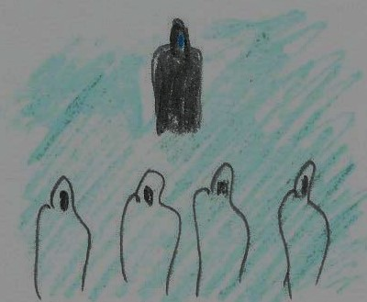
Counter-attack
Raven addresses the warriors
Raven: You are among the best and brightest of the warriors at the Academy. That is why you’ve been selected to help us end the threat posed by those demons. Be warned, we could be walking right into a trap, this mission will be dangerous. If you wish to step aside, I shall understand (the warriors stand firm) excellent. You have each been armed with a weapon; at close range these should easily find their mark. Are you ready? (The warriors nod, Raven uses his staff to open a portal) then let us begin

With Raven leading the charge, the warriors, including several from other factions attack the demons, Armsa, Sileb, Landrek and Yvarina each dispatch a demon close by. As they reload their crossbows, Tregan, Worbon and Jedren dispatch one of their own

Raven dispatches several demons with his staff and the other warriors are also having success dispatching demons. The warriors step aside to avoid the demons’ grasp as they reload and fire once again, at such a short range, their success is assured

With the demons weakening the warriors look in a great shape to take victory. Raven seems concerned. This battle is too easy. The warriors dispatch another dozen of the demons as a black cloaked figure comes out of the shadows

The black cloaked figure laughs in a way that Raven finds disturbingly familiar as the warriors focus their ammo on it. The figure is able to stop the arrows in mid-air and turn them back on their shooters, the warriors dive, barely dodging the attacks.

Raven focuses his fire on the black cloaked figure, the cloaked figure doesn’t appear to be fazed by the attack. He raises his hands and suddenly the demons begin to glow. The demons are suddenly invulnerable to the warriors’ arrows.

With the demons now at the advantage they press it, other warriors try and fire but the arrows are redirected. Armsa is pierced through the shoulder, Yvarina takes a shot to the leg, Worbon is pierced in the foot. Raven opens a portal and orders a retreat but the demons are moving forward.

Raven: Quickly warriors, through the portal! Retreat!

Unfortunately, Jedren is among those claimed. The remaining warriors retreat through the portal. Raven tries to follow but is stopped by the black cloaked figure, he is their prisoner now.

Sileb: We lost Jedren... He was one of our strongest warriors, it was crushing, knowing that he'd been so active just a few moments before. Not only that, but Raven's still out there! We certainly cannot abandon him, but we have three injured warriors. It's downcast right now, but we will fight back! And we will stop these games!
Landrek: This is definitely had a huge impact on the level of confidence amongst the team. Losing Jedren is definitely going to be a bitter pill to swallow, but hopefully we should be able to back from this defeat and put a stop to these games once and for all.
Tregan: The attack failed, it’s heart-breaking to have lost Jedren but Armsa, Yvarina and Worbon are also down, we need to make this right, and we have to do it quickly, or this will be for nothing

Raven: Who are you?
XXX: You can't tell? Disappointing (he uncloaks and reveals himself, Dominor, although with multiple mechanical components) surprise! (He laughs evilly as we pan out)

TO BE CONTINUED

