5 of 12

Scene 1
Warrior Academy, 11th May 06:15 BST
Rolfe finds Billy in the computer lab
Rolfe: It’s funny, I thought you were Oracle, pretty sure Gemma did too
Billy: Rox Ven does too but I’m not him. I’ve been looking into him, and I’m not sure how he avoids Rox Ven but…
Rolfe: He has connections across the globe, suggests some involvement with intelligence. Any word from James?
Billy: No… Haven’t seen or heard from him since he left Earth.
Rolfe: Damn, we could really use the United Alliance right now
Billy: Rox Ven legally owns the planet, I’m not sure how willing they’ll be to interfere.
Rolfe: Hh, “legally.” He took control of governments by impersonating their representatives until he had full control, hardly legal.
Billy: Never-the-less, we’ll have to fend for ourselves. Rox Ven’s been tracking me down, I’ve managed to give him the slip but I’ve run out of safe-houses
Rolfe: You can stay at the Academy for now
Billy: I’ve heard about that little squad, you think they can be trusted?
Rolfe: They haven’t let us down so far, and tomorrow might be their biggest day yet.
Billy: Oh?
Rolfe: Gemma decrypted the files they retrieved yesterday, Rox Ven has a data storage unit off the coast of New Zealand, it could contain vital information if we can hack their servers
Billy: I don’t know, doesn’t this all sound a bit easy?
Rolfe: Perhaps, but we have to keep moving forward.
Billy: Don’t let it get personal, Rolfe. We know what happened last time. Rox Ven knows how to use that against you.
Rolfe: I won’t.

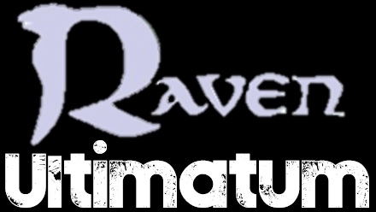

2 hours later
Raven, Gemma and the warriors are gathered
Raven: Warriors, today we commence an important operation. Operation: Hall of Knowledge. Oracle has managed to gain the schematics of the building. There are nth metal samples within the building preventing me from accessing it directly via portal. However, Oracle has arranged a military transport from New Zealand to take you over the base. Once you arrive, you’ll need to split up, alpha squad will need to hack the security terminals to prevent re-enforcements being alerted, beta squad will need to secure the chamber by taking out all the patrolling guards. Once you reunite, downloading the data should be straightforward. But in case it isn’t (he hands Actar the pento-star) this should help. Are you ready? (The warriors nod) then may the luck of the Raven’s eye be with you (he opens a portal and the warriors walk through)

Scene 2
Data Storage Unit, 21:00 NZT

The helicopter carrying the warriors flies towards the base. Maintaining an altitude above the range of the defences it manoeuvres into position above the landing platform used to transport guards and supplies into the base. The doors open and the warriors stand ready to make a leap.

Valtho, Nasrec, Faeyra, Galden, Ulran, Chepal, Sorto and Actar all instantly make the jump. Sonrel and Jephal look with fright at the task set before them. The other warriors fall in range of the defences, but gravity is moving them too fast for the defences to lock onto them. The helicopter maintains position as Sonrel and Jephal still stand

Sonrel looks again and sees the warriors who have jumped all have their parachutes deployed now they’re below the range of the base’s air-defences. Sonrel plucks up his courage and decides to jump, he launches himself from the helicopter and begins his freefall. The blasts aimed in his direction do nothing to dampen his courage.

Jephal remains in the helicopter, looking terrified about the challenge that faces him. Sonrel reaches a low enough height and his parachute deploys. Valtho, Nasrec, Faeyra, Galden, Ulran, Chepal, Sorto and Actar approach the landing platform and land safely. Sorto, Chepal and Actar quickly reach a terminal and begin hacking to help them get inside.

Sonrel is the next of the warriors to make a landing but the terminal still remains unhacked. A missile is fired from the building and hits the helicopter, destroying it. It staying still so long had allowed the missile to lock onto the target. The remaining hackers finish their job and they run into the building.

Sorto: It felt very exhilarating to make the jump, but also extremely sad to lose Jephal, as he's been an asset to this quest so far and his loss will make things all the harder.
Valtho: It was nerve-wracking standing over the base but I knew I had to do the challenge and I'm not afraid of heights. We were doing well but Sonrel and Jephal were very hesitant. I was pleased to see Sonrel touch down after us but it was heart-breaking when we heard an explosion and saw the helicopter destroyed. Losing a warrior so early on in the day was a very tough pill to swallow but we had a job to do.
Galden: The nerves were definitely kicking in before the jump was made, but once the initial shock value of the size of the jump receded it was an interesting experience to behold. However, it was made all the more aggravating when we lost Jephal, as losing someone to a basic primal fear is all the more unfortunate. Here is hoping we can recover from this minor setback.
Sonrel: Making the jump was difficult for me due to my slight fear of heights, though seeing that the others do it first it was just enough to make me jump. It's a great shame to have lost Jephal, particularly since his loss was beyond his control.
Actar: I'm not that scared of heights but the jump from the plane was nerve-wracking and I'm absolutely gutted we've lost Jephal because it's another warrior down and things are only going to get harder.
Chepal: I didn't really have any fear of heights at all, however you would never know when you would be shot out of the air like this. Jumping off the plane was very cool indeed and I did think all of us would make it so it was a nasty surprise when Jephal didn't make it. Losing a warrior was always going to make a bad effect on the team, and a lot of me felt that he really should have tried harder to have made the leap itself, but I know he would have been vital in completing the missions itself. What made this sad was that he was the first of the hackers to be claimed but I am confident there will be no more casualties this day.
Ulran: I was obviously very used to jumping into thin air before so I knew I was definitely going to take the leap, I must admit it was a thrilling experience and one I could look back on when this quest would eventually come to an end. After I have jumped off the plain, all of us were on a high after I have made the jump, so it was a horrible shock when Jephal was still on the plain when it was blown to smithereens. On this quest, I have never experienced a loss on this quest before, which was made worse that I got on so well with Jephal throughout the entire quest, but just for him we will pull together and complete the quest in his memory.

Scene 3
Raven’s quarters, 12:00 BST
Raven gazes at the runes in the book
<Raven>: There must be something regarding translation (he flips through the book) I don’t understand a word of it, how am I supposed to… (His staff glows and the book flips to the third page, there is a strange symbol glowing brightly on the page) ok (he lifts his staff and finds it, without much of his input crafts the symbol and pushes it through the book, Raven looks and finds he can understand it, he smiles at this thought as he reads through the book)

Scene 4
Data storage unit, 22:15 NZT

The Panels

Alpha squad, consisting of Sorto, Actar, Chepal and Faeyra enter a corridor. They see 8 terminals which the hackers will need to hack for them proceed. With Sorto being covered by Actar at the far end on the left, Faeyra covering Chepal near the near end on the right, they begin the challenge. As they begin to hack, robot guards begin appearing.

Actar and Faeyra draw their weapons and begin firing, lest they have to leave the side of the warriors. Neither of them have much success hitting the robots and by the time they have been dispatched, more have appeared. Knowing that the guards were coming from a single location, they both put their guns away and engage physically.

Both Sorto and Chepal have hacked a terminal and move quickly onto another one whilst Faeyra and Actar continue their fight. Actar is able to dispatch some with powerful blows, but has sustained a hit in the process. Faeyra has been more successful in avoiding their moves but his strikes do not carry as much impact.

Sorto and Chepal move onto their third terminal, 30 seconds have passed since they hacked the first terminal. Sorto wants to draw his weapon to help but the others encourage him to keep going. Faeyra and Actar risk being overwhelmed by the robot guards as more and more arrive. Faeyra is holding her ground but Actar is beginning to tire.

With 6 of the 8 terminals hacked, Sorto and Chepal each hack what they hope to be their final terminal. Faeyra lands a hard kick to a robot’s knee, weakening it, the second kick sends it into one nearby Actar. Sorto and Chepal complete the hack but find that the terminal opposite them, the first their team-mate had hacked had reset.

With little time to waste, Sorto and Chepal change sides and begin hacking the remaining terminals, Actar sustains a second hit from the robots as Faeyra dispatches another two. Sorto and Chepal complete the hack, shutting the door to any further guards. Sorto and Chepal help take out the guards that remain.

Sorto: I think we did well with the panels as our strategy was sound and were able to hack the terminals relatively quickly. I was quite proud of my role in that. We noticed that one of them had reset, but it didn't take us long to sort that out.
BActar: I'm very happy with how we handled this challenge, particularly after losing Solex - I think we made the best use of the resources we had available.
Chepal: The reason all of us completed the challenge was because we had the best strategy in which two of us was to hack the computers whilst the others would engage combat with the robots themselves. Looking back, one warrior hacking would have been a big mistake so Sorto deserves a lot of credit as he was the warrior who thought of the strategy in the first place, I did think that Actar at one point should have been doing the hacking and I could have engaged the enemies with my superior combat skills, however it didn't really matter as the team worked well in the first place. I am now starting to gain some real confidence as both sides would join with each other soon, meaning the advantage would be on our side.
--------------
Guard Bots

Beta squad, consisting of Valtho, Nasrec, Sonrel, Galden and Ulran approach a section of the building that’s heavily guarded. Valtho sends out one of Gemma’s drones to scan the area and provide them with a full layout of the building. One shows in front of the warriors and they devise a strategy to take them all down. Valtho heads this operation.

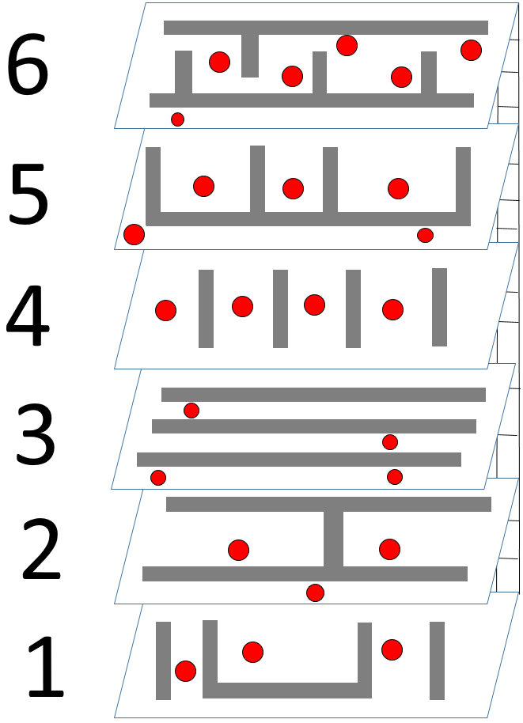
Key
Red Dots – Guards
Grey rectangles – desks
Ladder - Staircase

Valtho hides behind the desk closest to him, when the robot isn’t looking he strikes, taking it down silently. Nasrec and Sonrel head across the room so they are not too far from their respective guards. They both make their move and take them down. With the floor cleared they head to the staircase and move up to the next floor.

Nasrec and Galden head to the left side of the room, Valtho and Sonrel remain on the right side, whilst Ulran stays in the middle, observing both guards behind the desks. When they’re facing away, he gives a signal for them to strike and knock them down without being heard. Both pairs move forward but Sonrel is the one to take down the final guard

They move up to the third floor, they split similarly to before with Nasrec and Galden heading left, Valtho and Sonrel remaining on the right. Ulran cues Nasrec to strike, taking down the first guard before allowing Valtho to take down the second guard. Both teams position themselves behind the row of desks and make their move, taking down the final 2 robots on this floor.

The warriors reach the fourth floor. They split into pairs again but both stay on the right side of the room. With the robot looking at neither team, Sonrel strikes and takes down the first robot. Valtho moves in and takes down the second behind the next set of desks. Nasrec takes down the third guard and Sonrel takes the fourth down.

On the fifth floor, the warriors are faced with a difficult test, now there are 5 guards and 3 are in separate rooms. Ulran remains near the staircase as the others move in. Valtho on his own takes down a guard near the right corner of the room whilst Galden and Sonrel begin ambushing the 3 robots in the rooms.

They come dangerously close to being caught but are fortunately successful. Ulran gives the signal for the final guard to be taken down by Sonrel. They move up to the final floor. Nasrec and Galden head to the end of the room. Upon Ulran’s signal Nasrec moves in and takes down the guard on the bottom part of the room.

Ulran gives a signal and Galden and Valtho take down the guards closest to them. Valtho narrowly avoids being spotted by the nearby guards. Nasrec and Galden head around the room and eye the nearby guard. Sonrel manages to take him and take it down silently. The pairs make eye contact opposite each other and near the final enemy. They strike, destroying the final robots.

Ulran: I opted not to take out any of the guards because even though I am confident anyway that we would end up completing the mission anyway, I didn't think my speed was good, so I thought "It is only one challenge, sit out of this one and do well in the next challenge." I opted to do the signalling anyway, because I do feel confident when it comes to gestures with my hands. I did feel that the warriors including myself ought to have done better as there were quite a few close shaves during the challenge itself, though it didn't matter much in the end as we all have completed the challenge with minimal detection anyway.
Sonrel: We worked well as a team though I think I could have made somewhat better use of my stealth.
Valtho: Well that was a very difficult challenge right from the beginning as despite the drone scan it wasn't easy to see where everything was. I had a decent idea of how to complete each floor and so I tried to take the lead on our strategy. It was smooth sailing until the fifth floor but it got very tricky from then on as all the guards were very close together and we didn't want to make too many sudden movements unless we all moved together as there was a risk of tripping. We dodged a bullet on the fifth floor and made it to the final floor. I was close to being caught at one point but we were successful in the end. I was really proud with how we did as a team and how I did personally as my stealth can let me down at times.
Galden: Given the circumstances provided by the surrounding environment I personally thought that the team did extremely well working off Valtho's strategy. However, we could have handled our environment a little better, as we may have been able to improvise cover more often had we considered using them more often.

Scene 5
Warrior Academy, 14:00 BST
Gemma is looking through the files from the flash drive, Rolfe comes in
Rolfe: There anything else useful on that drive?
Gemma: Schematics for an upgraded robot model with heavier armour. I don’t think the warriors’ blasters will affect it. (Billy comes out) I didn’t know you were here
Billy: I might be able to help with that. S.H.I.E.L.D. recently issued a new mandatory combat amour, it’s protocol to study them and work out how they work. I might be able to upgrade the warriors’ versions with a few new features to help out. Assuming they make it back, of course.
Gemma: Thanks for the vote of confidence (the room shakes briefly) what was that? (She and Rolfe look at each other) Raven (they rush to Raven’s quarters and find his room largely destroyed)
Raven: This book could be the key to ending this. It tells of a long-lost magic that I might be able to master. (He notices the damage) But, evidently, I should do this outside (he grabs the book, transforms, and flies away)

Scene 6
Data Storage Unit, 04:00 NZT

Enforcer

Everyone looks for cover as the enforcer approaches them. Galden tries to draw his attention with his blaster but it’s ineffective and he’s soon out of shots and needs to recharge. Sorto and Chepal take cover on the right side as Sonrel and Faeyra make a move for the pieces. Ulran and Actar take cover on the left as Valtho and Sonrel head for the shards on the right.

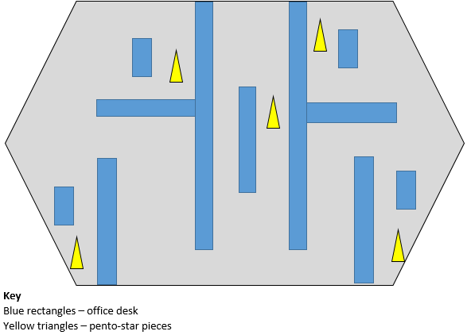

The enforcer patrols the middle corridor, ignoring the shots fired by Galden entirely. He soon realises his ammo is being wasted and puts his weapon away, he narrowly avoids the enforcer’s blasts as he heads for cover. Faeyra grabs the piece of the far right of the room, Nasrec manages to grab the piece on the far left of the room.
Galden takes cover with Sorto and Chepal. Sonrel and Valtho each manage to gain pieces of the pento-star but the final piece is in the centre of the room, where the enforcer is making his primary patrol. Valtho has an idea and whispers his plan to Sonrel. They agree on the plan and prepare to put it in motion.

Sonrel heads to the left side of the room, temporarily gaining the enforcer’s fire, Valtho uses this distraction to grab the final piece of the pento star, but soon he becomes the target of the enforcer, he dodges several blasts but he is eventually hit and knocked backwards. He recovers, still holding the piece as the enforcer is about to blast him again.

Chepal charges at the enforcer, pushing it away from Valtho, allowing him to get back to his feet. Chepal takes a hit as he tries to return to cover. Valtho heads to the right-hand side of the room, and suddenly the enforcer is firing upon that area, Sorto and Chepal back away to avoid getting hurt.

Valtho, Sonrel, Faeyra and Ulran now hold the 5 pieces of the Penta-star. They combine the pieces together and it magically reforms, they place it on the chest of the enforcer and all his systems short out. Sorto, Actar and Chepal quickly begin to hack the data server and draw any information they can.

Galden: Acquiring the information in this complex was definitely much harder than the group had anticipated, as the enforcer proved to be a powerful roadblock to overcome. Personally, I felt like a bit of an idiot for not taking the hint that the armour was withstanding the blasts of the charge pistol, but I was primarily acting on gut instinct so maybe a more calculated approach is needed for future encounters.
Valtho: This was another tough challenge as the enforcer was much stronger than we were and I was quite worried one of us would be eliminated unless we all split up into cover. It turned out to be relatively simple to get the first four pieces, but the last piece proved much more difficult. Luckily Sonrel and I came up with a plan and it helped a lot. It was very scary to get hit from such close range, but I owe one to Chepal for putting his body on the line to save me. Any information that we gained from this challenge was definitely worth it as we need all the help we can get.
Sonrel: I'm not sure how the information will help - we haven't looked at it yet, though I'm hoping it will be useful.
Actar: I've no idea yet how the information we've gathered will help us but every bit of information can be used somehow and everything we wrest from Rox Ven feels like a victory.
Chepal: The information we have just gathered is going to be of crucial importance for the next few days, with this piece of information, I think all of us will be invincible so I really can't wait for the end to be in sight which shouldn't be too far away now. On gathering the information, itself, doing so was rather easy and for once I felt the whole team really worked well together so we were always going to complete this challenge, no matter what the dangers were. I opted to protect Valtho when he was knocked down as I was determined not to lose another warrior in this quest and there was no way we were going to lose something precious we have already collected. Besides, destroying that alpha robot was awesome, and I definitely love it when things get destructive.
Ulran: The whole team really pulled through together which was because we all had a strategy beforehand and perfect teamwork was in place throughout. Some of us like me included opted not to risk anything in facing the alpha robot as I knew some of us were no match for that monstrosity and some of us would have been killed if we did that. I have to give a lot of credit for my own brother, saving a warrior from certain death just proved himself a true team player but Galden also worked his own socks off to get everything together for this mission to be a success. Gathering this information has given all of us a confident boost as things can only go up from this point onwards.

Scene 7
Warrior Academy, 18:00 BST
The warriors are returned through Raven’s portal, Actar hands Gemma a data drive
Gemma: Well done, warriors, with this intel we could strike hard against Rox Ven. Your meals are prepared for you in the kitchen (they head off to eat)
-------------
The Courtyard, 2 hours later
Raven uses his staff to craft a triangle, with a straight line down the middle, the area around him glows gold. Gemma approaches but is caught by the force-field, she stands back as Raven creates 4 crosses and joins them together in a square, it pushes forward and upon impact each corner explodes
Gemma: Most impressive (Raven turns around)
Raven: I didn’t see you, my apologies
Gemma: We might be onto something big this time, the data from New Zealand gave us the location of Rox Ven’s central hub. We’re modifying the suits to attack it tomorrow. (Raven smiles then returns to his book)

